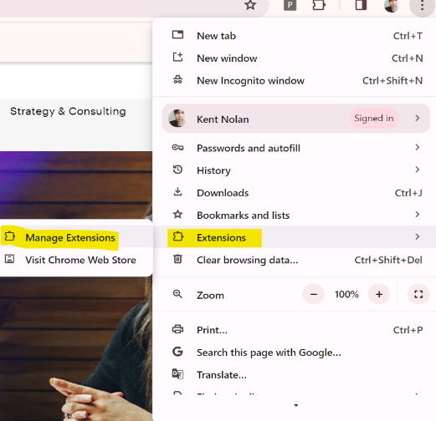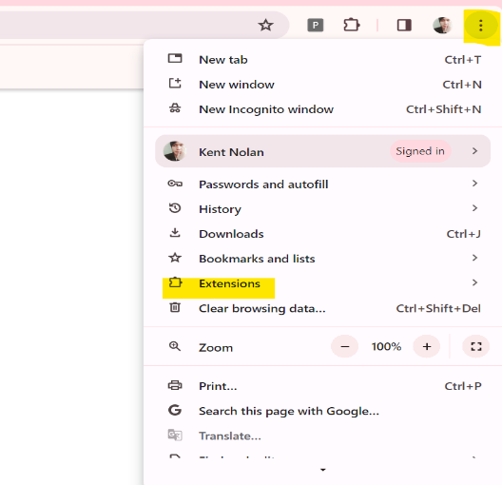Setting up a Local Browser Extension.  
  
**Step 1.**  
Go to Browser Settings > Extensions > Manage Extensions.

**Step 2.**  
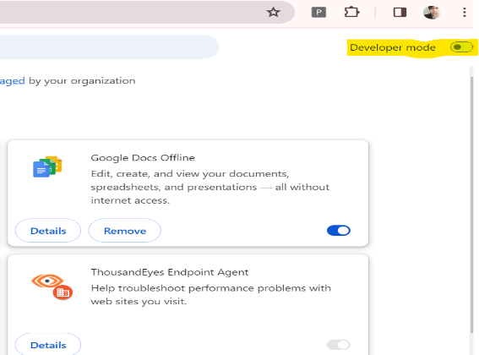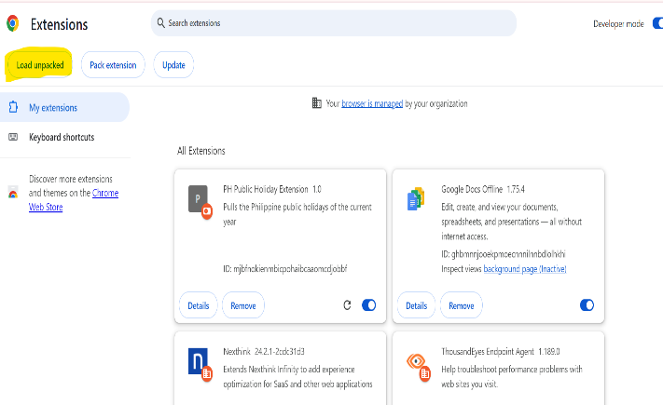Under Manage Extensions turn on **“Developer Mode”**. Once the Developer Mode is on, click on **“Load Unpacked”.**

Step 3.  
Open the build folder and **“Select Folder”** to upload the app on your browser Extension. Once uploaded you can pin the extension on your local browser.

